## Process patterns

Processes themselves stand to the independent continuants which are their participants as qualities stand to the independent continuants which are their bearers. However processes also manifest process patterns of various sorts. This means that a process of running, for example, can be asserted to be a process *of* *increasing speed*, *of decreasing speed*, *of constant speed*, and so forth. Our underlying approach to dealing with such assertions is to define corresponding families of syntactic classes of what we shall call *process patterns*. Thus to assert:

*p* **has-process-pattern** *increasing speed* =def.*p***member-of-syntactic-class {***x* is a *process* & *x* occupies temporal region *t* & the speedof *x* is continuously increasing across *t*}

where

the speedof *x* is continuously increasing across *t*

is defined in the usual mathematical way (this definition will be added to the ‘Rates’ document here: <http://ontology.buffalo.edu/bfo/rate.docx>, which will form the nucleus of a catalog of process pattern definitions).

The processes with which experimenters have to deal are typically complex in nature, and this means that they typically have measurable dimensions, and associated process patterns, of multiple different types. The Wiggers diagram, for example (see Figure 10), illustrates the cardiac processes occurring in the left ventricle in a single beating of a human heart. This figure tells us that each successive beating of the heart is such as to involve change along (at least) six different dimensions, corresponding to measurements of *aortic pressure*, *atrial pressure*, *ventricular pressure*, *ventricular volume*, *electrical activity*, and *voltage*, respectively. (Here voltage is used as a proxy for the intensity of sound.) As de Bono, *et al*., point out, these measurements reflect the variables encoded in models of human physiology created by scientists using ordinary differential equations [85].

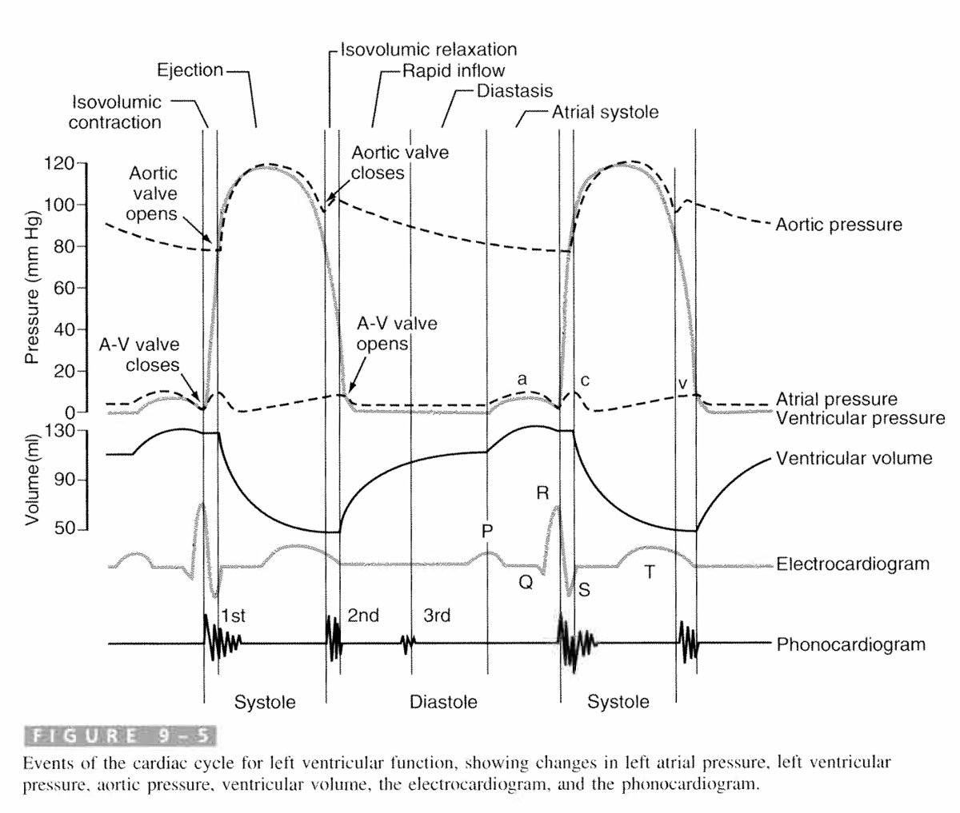

Figure 10. A Wiggers diagram (from Guyton, *Medical Physiology*)depicting: Events of the cardiac cycle for left ventricular function, showing changes in left atrial pressure, left ventricular pressure, aortic pressure, ventricular volume, the electrocardiogram, and the phonocardiogram.

The Figure illustrates how, when measuring activity in a complex system such as a human organism, it is variations only along specific structural dimensionsof the corresponding whole process to which our measuring processes and the resultant measurement data relate. Other dimensions can be added to those depicted in the Figure, such as the dimensions of change in volume and shape of the chambers, which manifest obvious interdependences. In the *running* case, similarly, different measuring processes may be directed to different dimensions of change within the whole process, pertaining to *speed of motion*, *energy consumed*, *oxygen utilized*, and so forth*.*

### Process patterns manifested by quality changes

If the measured values of temperature or weight are increasing over time, then we say that the processes in question manifest *process patterns* of *increasing.*

*Process patterns* of these latter sorts, *process patterns* along dimensions of change in some single quality, can be represented by means of a graph in which measures of that quality are plotted against time. (We would of course need to address in a full treatment the complexities that arise when we take account of phenomena such as averaging, interpolation and measurement error typically involved in the process leading to the creation of such graphs.)

Some process patterns, because they reflect interrelated dimensions of change within the same underlying processes, will themselves be connected through what we can think of as relations of dependence. When John is exercising and at the same time John is participating in a compression sock testing process, then the process pattern which is manifested John’s performance of the test is mutually dependent on the process pattern manifested by John’s exercising. When heat is applied to a volume of gas in a closed container then the pressure of the gas will rise; when we measure the rise in temperature and in pressure of the gas then we identify two distinct process patterns of a single whole process. Here the process patterns involved are: *increase in pressure of gas* and *increase in temperature of gas*, respectively.

Of course these process patterns are manifestations of the same phenomenon viewed at a lower level of granularity – the increase in average kinetic energy of the gas molecules – they reflect parts (streaks, strands, what are called ‘process profiles’ in [97]) within this phenomenon, upon which cognition is focused when the corresponding measurements are taken. BFO 2.0 does not recognize such strands as a separate category. Corresponding data should be annotated with BFO:*process* together with associated *occurrent_part_of* and *has_process_pattern* assertions as needed.

### Speed process patterns

example(process profile)[We have mentioned already quality *process patterns –* these are patterns manifested by changes along some single quality dimension, for example patterns of increase or decrease in temperature or height, cyclical patterns of color change . On a somewhat higher level of complexity are what we shall call *rate process patterns*, which are the targets of selective abstraction focused not on determinate quality magnitudes plotted over time, but rather on certain ratios between these magnitudes and elapsed times. A speed process pattern, for example, is represented by a graph plotting against time the ratio of distance covered per unit of time. Since rates may change, and since such changes, too, may have rates of change, we have to deal here with a hierarchy of process patterns at successive levels of complexity], including:

|  |
| --- |
| * speed pattern   constant speed pattern  2 mph constant speed pattern  3 mph constant speed pattern  increasing speed pattern  acceleration pattern  constant acceleration pattern  32ft/s2 acceleration pattern  33 ft/s2 acceleration pattern  variable acceleration pattern  increasing acceleration pattern |

and so on.

Definitions of the corresponding syntactic classes will be correspondingly cumulative, thus for example an increasing acceleration pattern will be defined as a variable acceleration pattern manifested by a given process of movement over a given time interval in which the magnitude of the movement’s acceleration is increasing over that interval.

In a full treatment we would need to add a dichotomy between scalar and vector process patterns. Speed belongs to the side of scalar process patterns – speed is a constant ratio of a distance travelled per unit of team, independently of the direction of motion. The corresponding *vector process patterns* incorporate the direction of motion, yielding under *acceleration pattern* subclasses such as *centripetal acceleration pattern* (for acceleration along a curved line), *linear acceleration pattern* (for acceleration along a straight line), and so on.

In all the this reader must bear in mind that while the ratios in the examples mentioned will need to be referred to using specific units of measure, these ratios are in fact unit-specification independent. If the measured value for speed of a certain 4 minute run is 4 *miles per minute*, for example, then we have identified the 4 *minute* 4 *miles per minute process pattern* by means of the units *mile* and *minute*; however we could equally have identified the same process pattern as a 240 *second 6437.38 meters per second process pattern*.

### Beat process patterns

Example(process profile)[One important sub-family of rate process patterns is illustrated by the patterns exhibited by repeating processes, where frequency (beats per unit of time) takes the place of speed (distance travelled per unit of time).

Each such process manifests a beat process pattern – potentially a whole hierarchy of beat process patterns along the lines of:

rate process pattern

beat process pattern

regular beat process pattern

3 bpm beat process pattern

4 bpm beat process pattern

irregular beat process pattern

increasing beat process pattern

and so on.

In the case of a regular beat process pattern, a rate can be assigned simply by dividing the number of cycles by the length of the temporal region occupied by the beating process pattern as a whole. However it is the irregular process patterns, where such an analysis is inadequate, which are most often of diagnostic significance, for example when they are identified in the clinic, or in the readings on an aircraft instrument panel.]

### Process patterns attributed to processes at a time

In the case of all process patterns in all three of the families distinguished thus far – namely quality, speed and beat process patterns – measurement data are often expressed not in terms of the pattern manifested by some process across an extended temporal interval, but rather in terms of what holds at some specific temporal instant. The latter is then defined in terms of the former in the following way:

(5) John’s running **has-process-pattern** *speed* *v* **at** time instant *t*

(5) asserts, in first approximation, that there is some temporal interval (*t*1, *t*2), including *t* in its interior, in which the speed *v* process pattern is instantiated. More precisely (in order to take account of the fact that John may be moving with a continuously changing speed in the neighborhood of *t*), (5) must be formulated in something like the following terms:

(6) Given any ε, however small, we can find some interval (*t*1, *t*2), including *t* in its interior, during which the speed *w* **at** which John is moving is such that the difference between *w* and *v* is less than ε.

For more details see again the still provisional material on rates [here](http://ontology.buffalo.edu/bfo/rate.docx).

Note that the logical significance of the ‘**at** time instant *t*’ in (5) is distinct from what it is, for example, in

1. John has temperature 64° Celsius **at** time instant *t.*

In (7), we are using ‘**at** *t*’ as part of an assertion concerning the instantation by an individual of a continuant universal; in (5), we are using ‘**at** *t*’ to pick out a part of a process which manifests a certain process pattern – where the instantiation relation itself is (as it were) timeless. The determinate continuant universal involved in (7), namely: *temperature of* 64° *Celsius*, is non-rigid, because John’s temperature can instantiate different such determinate universals at different times. The process pattern referred to in (5), namely: *motion with speed v* is manifested by the given process at *t* but not at *tˊ* because, while the whole process manifests only one speed process pattern when taken as a whole, it can appear that one and the same motion instantiates different such determinate universals at different times because it has different parts which unfold successively in time. To say that a single motion *m* can be now quicker now slower is not to make a statement analogous to: John can be now warmer, now colder. Rather it is to make a statement of the form: *m* has two parts, a slow one and a quick one. Where speed is increasing continuously, it is as if the process has a whole has continuum-many parts.